CHAPTER 2-7

kleene's theorem

Generalized Finite State Machines

- An NDFSM can read 1 letter at a time. The NDFSM which accepts only the word baa is:
-

+
b a a

- We will make 1 relaxation to the definition of NDFSM and arrive at a new kind of nondeterministic machine we call generalized FSM (GFSM): While an NDFSM can read 1 input letter at a time, a GFSM can read any number of letters at a time.
- We can build the machine that accepts only the word baa as follows:
-
+
baa

The above GFSM is nondeterministic since it must decide how many letters to read each time it reads. Suppose the input string is baa. It must make 1 of the following choices:
- read 1 letter and crash.
- read 2 letters and crash.
- read 3 letters and go to the + state and accept the string.
- A string is accepted by a GFSM if there is some way it could be accepted.
- Every NDFSM is a GFSM. A GFSM may not be a NDFSM (does not allow string-labeled edges).

Ex2-7-1 GFSM accepts all words in which the a's occur only in even clumps and end in 3 or more b's
-
+

bbb

b, aa

Ex2-7-2 GFSM accepts EVEN-EVEN
aa, bb ab, ba aa, bb
±

ab, ba

- Instead of listing all the strings out separated by commas, we will use REs as language labels.

Ex2-7-3 GFSM accepts EVEN-EVEN
aa∪bb ab∪ba aa∪bb
±

ab∪ba

Ex2-7-4 GFSM accepts all strings without a double b
a b b
±

+

a

Ex2-7-5 Build a GFSM that accepts all odd length strings that end in a.
a
-
+

aa∪ab∪ba∪bb

Ex2-7-6 Build a GFSM that accepts all even length strings that end in a.

aa∪ab∪ba∪bb
a∪b
-
+

a

GFSMs in desirable form

Theorem Any GFSM that accepts a nonempty language L can be converted into an equivalent machine but with the following properties:
- It has 1 unique start state that has no incoming edges.
- It has 1 unique final state that has no outgoing edges.
- The unique start state is different from the unique final state.

………..
-
+

Any GFSM with the above property is said to be in the desirable form.
Proof Consider any GFSM T.
- If T violates 1, introduce a new start state and connect it to the old start state by ε-edge. Drop the – symbol from the old start state.

If T violates 2, since T accepts a nonempty language, T has 1 or more + states. Remove + from old + states and introduce a new + state and connect from all old + states to the new + state with ε-edges.
- If T violates 3, introduce a new start state and connect it to old start state by an ε-edge. Drop - from the old start state.

Ex2-7-7 GFSM accepts EVEN-EVEN that is in desirable form
-

ε
aa∪bb ab∪ba aa∪bb

ab∪ba
ε
+

Theorem Any language that can be defined by RE or NDFSM or GFSM can be defined by all 3 methods.

Proof If A, B, C are sets, and if A⊆B⊆C⊆A, then A=B=C. Thus, the 3 parts of our proof will be:
Part1: Every NDFSM has a corresponding GFSM that defines the same language.
Part2: Every GFSM has a corresponding RE that defines the same language.
Part3: Every RE has a corresponding NDFSM that defines the same language.

Proof of part 1 Every NDFSM has a corresponding GFSM that defines the same language

Every NDFSM is itself a GFSM.

Proof of part 2 Every GFSM has a corresponding RE that defines the same language

We will use a constructive algorithm to prove this. Consider GFSM M.

Remove from M any states that are not reachable from the start state.

If M has no final states, then the language generated by M is accepted by RE φ and we are done.

Otherwise, convert M to desirable form.
- Make sure that each state has at most 1 loop, and pair of nodes has at most 1 edge between them going in 1 direction:
r₁∪r₂∪r₃
r₁
x
becomes
x
r₂ r₃

r₁ r₁∪r₂
1
2
1
2
becomes
r₂

- Use the bypass and state elimination operation to eliminate every internal (not + or -) node.
r₁ r₂ r₁r₂
1
2
1
3
3
becomes

r₁ r₃ r₁r₂*r₃
1
2
1
3
3
becomes

r₂

r₃ r₁r₂*r₃
3
3

r₁ r₄ r₁r₂*r₄
1
2
1
4
4
becomes
r₁r₂*r₅
r₂ r₅
5
5

- In general, to eliminate a state say, 2, list all incoming states (say, 7 and 9) and all outgoing states (say, 11 and 4). State 2 itself is never considered as an in-state or an out-state of 2. We then install bypass roads from each incoming state to every outgoing state. Thus, we must install routes 7 to 11, 7 to 4, 9 to 11, 9 to 4. What have we done to the GFSM? Without changing its language, we have eliminated 1 of its states.
- The process of installing bypass roads might create multiple paths in 1 direction between 2 nodes. Thus, redo step 4 after we have done step 5.
- Keep eliminating internal nodes until we have eliminated all internal states from M. We have a GFSM that looks like:
-
+
r

The resultant RE r is the RE that defines the same language M did originally. Note that if we eliminate the states in a different order, we could end up with a different looking RE.

Ex2-7-8 Eliminate 2:
r₃ r₂ r₄
1
2
3

r₁
To eliminate 2, we list the incoming states (1 and 3), and the outgoing states (1). We must install routes 1 to 1, and 3 to 1. So we have the following:
r₄r₂*r₃
1
3

r₁r₂*r₃

Ex2-7-9 Eliminate 2:
r₈

r₁ r₃ r₄ r₆ r₇
1
2
3

r₂ r₅

r₉
We want to eliminate 2 (incoming 1, 3; outgoing 1, 3). We must install routes 1 to 1, 1 to 3, 3 to 1, and 3 to 3. So we have the following (step 4 is done after step 5):
r₁∪r₂r₄*r₃ r₈∪r₂r₄*r₅ r₇∪r₆r₄*r₅
3
1

r₉∪r₆r₄*r₃

Ex2-7-10 The following GFSM accepts all words that begin and end with double letters having at least
length 4. Find a RE that generates the same language.
+
a∪b aa
-

+
aa∪bb bb

All states are reachable from the start state.

The language generated by M is not empty.
- M is not in desirable form. We introduce a unique final state with no outgoing edges:
2
a∪b aa ε
-
1
+
3
aa∪bb bb ε

- Each state has at most 1 loop, and pair of nodes has at most 1 edge between them going in 1 direction.
- Use the bypass and state elimination operation to eliminate internal nodes. Let us eliminate state 2 (incoming 1, outgoing +). We must install route 1 to +:

a∪b aa
-
1
+
3
aa∪bb bb ε

Let us eliminate state 1 next (incoming -, outgoing 3, +). We must install routes - to 3
and - to +:
(aa∪bb)(a∪b)*aa
-
+
3
(aa∪bb)(a∪b)*bb ε

Let us eliminate state 3 next (incoming -; outgoing +). We must install route 1 to +:
(aa∪bb)(a∪b)*aa
-
+

(aa∪bb)(a∪b)*bb

We arrive at:
(aa∪bb)(a∪b)*aa ∪(aa∪ bb)(a∪b)*bb
-
+

The GFSM defines the same language as the RE (aa∪bb)(a∪b)*aa∪(aa∪ bb)(a∪b)*bb.

Ex2-7-11 Find a RE that generates the same language as the following GFSM:
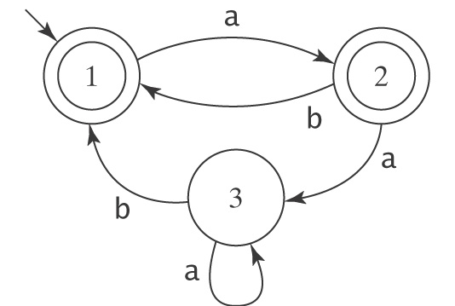

All states are reachable from the start state.

The language generated by M is not empty.
- M is not in desirable form. We introduce a unique start state with no incoming edges and a unique final state with no outgoing edges:
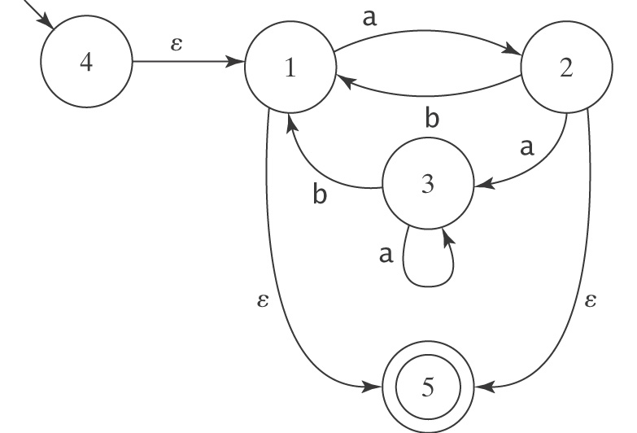
- Each state has at most 1 loop, and pair of nodes has at most 1 edge between them going in 1 direction.
- Use the bypass and state elimination operation to eliminate internal nodes. Let us eliminate state 3 (incoming 2, outgoing 1). We must install routes 2 to 1:
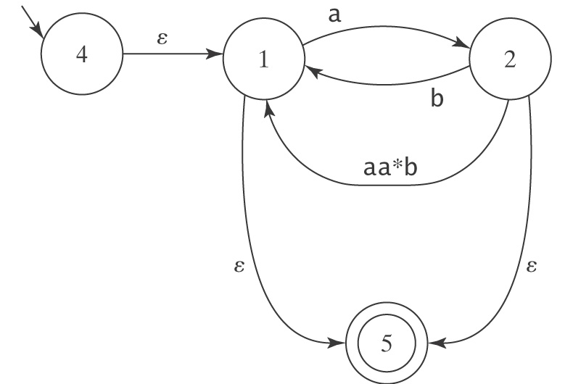
Combine the 2 routes from 2 to 1:
a
-4
1
2

ε b∪aa*b
+5
ε ε

Eliminate state 2 next (incoming 1, outgoing 1,5). We must install routes 1 to 1 and 1 to 5:
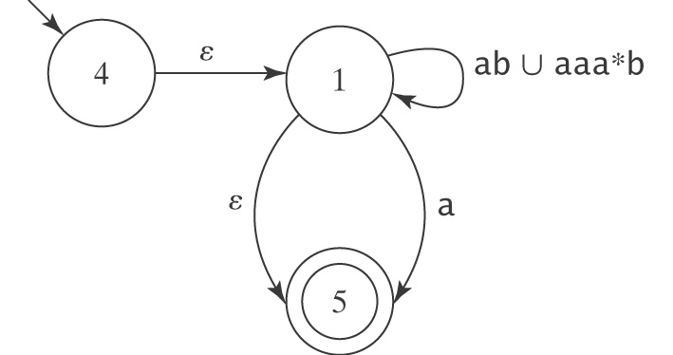
Combine 2 routes from 1 to 5.
-4
1

ε ab∪aaa*b

a∪ε
+5

Let us eliminate state 1 next (incoming 4, outgoing 5). We must install routes 4 to 5:
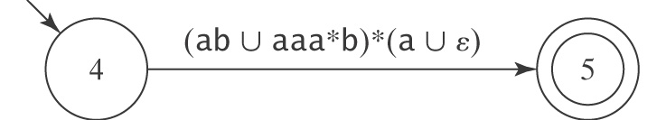

Proof of part 3 Every RE has a corresponding NDFSM that defines the same language

We’ll show this by construction.
- Recall that the regular expressions over an alphabet Σ can only be obtained by the following 8 rules:
1. ∅ is a regular expression.
2. ε is a regular expression.
3. Every element of Σ is a regular expression.
4. If α , β are regular expressions, then so is βα.
5. If α , β are regular expressions, then so is β∪α.
6. If α is a regular expression, then so is α*.
7. α is a regular expression, then so is α⁺.
8. If α is a regular expression, then so is (α).
  - As we build up a RE, we could at the same time build up a NDFSM that accepts the same language. To simplify the construction, we will assume that no regular expression uses rule 7 (since it is not necessary in that α⁺=αα*). In addition, as we build up a RE, we will build the RE based on the grouping that we want, and thus rule 8 is also not necessary for us to consider.
  - We will give 6 rules below (a-f) to construct a NDFSM that corresponds to rules 1-6 above:
- The following NDFSM in desirable form accepts φ (rule 1):
-

- The following NDFSM in desirable form accepts only ε (rule 2):
ε
-
+

- The following NDFSM in desirable form accepts only the letter x in Σ (rule 3):
x
-
+

Now, let NDFSM₁ in desirable form that accepts L(r₁) be:
-1
+11

Let NDFSM₂ in desirable form that accepts L(r₂) be:
-2
+22

- The NDFSM in desirable form that accepts L(r₁r₂) can be built from NDFSM₁ and NDFSM₂ and it is (rule 4):
ε
-1
11
2
+22

- The NDFSM in desirable form that accepts L(r₁∪r₂) can be built from NDFSM₁ and NDFSM₂ and it is (rule 5):
1
11
ε ε
-
+
2
22
ε ε

- The NDFSM in desirable form that accepts L(r₁*) can be built from NDFSM₁ and it is (rule 6):

ε
1
11
ε ε
-
+

ε

- Because of rules a-f, we know that all REs have corresponding NDFSMs that give the same language. This is because while we are building the RE, we can simultaneously build the corresponding NDFSM from the above constructive algorithms.

Ex2-7-13 Find an NDFSM that accepts L(r) where r= (b∪ab)*
NDFSM₁ in desirable form for a
a
-1
+2

NDFSM₂ in desirable form for b
b
-3
+4

NDFSM₃ in desirable form for ab
a ε b
-1
2
3
+4

NDFSM₄ in desirable form for b
b
-5
+6

NDFSM₅ in desirable form for b∪ab:
a ε b
1
2
3
4
ε ε
-7
+8

b ε
5
6
ε

NDFSM₆ in desirable form for (b∪ab)*

a ε b ε
1
2
3
4
ε ε
7
8
ε ε
+10
-9
ε
b ε
5
6
ε ε

- In practice, when we are to find a NDFSM that accepts L(r) where r is a RE, we do not usually start at the very beginning and construct NDFSMs for individual letters in Σ.

Ex2-7-14 Find an NDFSM that accepts L(r) where r=(a∪bb)*(ba*∪ε).
The NDFSM in desirable form that accepts L(a∪bb) is:
a
-a₁
a₂
+a₃

b b

The NDFSM in desirable form that accepts L((a∪bb)*) is:

a ε
a₁
a₂
a₃
+a₄
-a₀
ε b b ε
ε

The NDFSM in desirable form that accepts L(ba*∪ε) is:
ε
-b₁
b₂
+b₃

b ε
a

The NDFSM that accepts L((a+bb)*(ba*∪ε)) is:

a ε
a₁
a₂
a₃
a₄
-a₀
ε b b ε
ε
ε

ε
b₁
b₂
+b₃

b ε
a

- We have now shown that every language accepted by an NDFSM can be accepted by a GFSM, every language accepted by a GFSM can be defined by a RE, and every language defined by a RE can be accepted by an NDFSM. Thus, any language that can be defined by RE or NDFSM or GFSM can be defined by all 3 methods.

Kleene's Theorem The class of languages that can be defined with regular expressions is exactly the class of regular languages.
Proof By definition, the set of languages defined by FSMs is the set of regular languages. We have proven that every language that can be defined with a regular expression can be accepted by a NDFSM, and therefore regular. We have also proven that every language accepted by a NDFSM, hence a regular language, can also be defined by some regular expression. Thus, we have proven the Kleene's Theorem.

Homework problems

1. Build a GFSM that accepts the language of all words that begin and end with the same double letter, i.e., either of the form aa…aa or bb…bb. Note that aaa and bbb are not words in this language.

2. If L is a language that is accepted by a GFSM called G, prove that there is a GFSM that accepts the language of all strings of a's and b's that end in a word from L. Hint: construct such a GFSM.

3. Build a GFSM that accepts L(ab*aa∪bba*ab). Your machine cannot have more than 5 states.

4. Convert the following GFSM to RE:
+1
a b
+4
-2

a∪b ba ab
3

You must use the algorithm discussed in class and eliminate states in the following order:1, 4, 3, 2.

